University of California, Berkeley

CE 122/123L Bridge Design

Byzantine

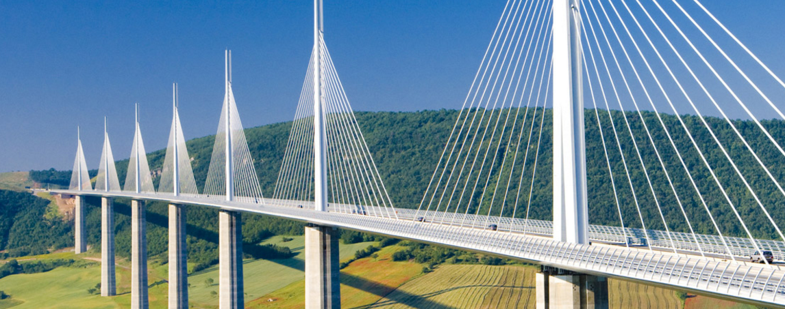

**Brian Tam**

**Omar Natouf**

**Shien Jinn Sam**

**Yanlong Ma**

**Yiqiu Zhang**

## 

## **Table of Contents**

**Table of Contents** **2**

**Letter of Transmittal** **3**

**Financial Proposal** **5**

Overview 5

Cable Costs 5

Deck Costs 6

Tower Costs 7

Total Costs per Material 7

**Technical Proposal** **8**

General Project Description 8

Structural system 8

Loading criteria and assumption 9

Materials 9

Geotechnical 10

Design of special conditions / elements 10

i.Superstructure 10

ii.Front Cable 17

iii.Back Cable 18

iv.Pylon 18

Foundation 19

East side foundation 19

Abutment 20

Constructability 25

**Appendix** **32**

## 

## Letter of Transmittal

Davis 502

Berkeley, CA 94720

Yanlong Ma, PhD

April 28th 2017

Professor Stephen Mahin

Professor of Civil Engineering,

University of California, Berkeley

Berkeley, Ca 94720

Dear Professor Mahin,

We are Byzantine, a structural engineering firm specializing in bridge design and construction. It has come to our attention recently, that there is an open design bid for the proposed J St. Bridge. Our team, consisting of professionally licensed structural engineers, is writing to submit our design proposal for the proposed replacement bridge.

Given the geographical conditions of the site and the required bridge span, we are proposing an asymmetric cable stayed bridge. Our extensive design considerations-to be expounded on briefly- captures the combined interests of all stakeholders in this project;environment, safety, constructability, and financing.

Our basic design considerations were to provide a safe, easily constructable and economical design that would have minimal disruption to the existing environment while maintaining a pleasing design aesthetic. These considerations are paramount as societies increasingly value reliability and sustainability. They are also an exercise in practicality. Due to the enormous financing costs of such structures, having an economical and easily implementable design would expedite the financing process and reduce the economic disruption of local communities typically associated with longer construction schedules. The site requires that the proposed structure span 525 feet over the Sacramento River. For this particular geometry, it is determined that a cable stayed design would be most economical. Furthermore, having a suspension based superstructure negates the need for multiple supporting structures and columns within the river below, easing construction and reducing the environmental impact on the existing river ecosystem.

Our design utilizes an asymmetric support system, with two towers on a single bank bearing the load of the entire deck. This design, while unusual has several key structural advantages- having the supporting tower be placed on the bank negates the need for expensive construction equipment and procedures to be carried out to construct the structure in the river below. Cable stayed designs are also much more efficient, having significantly lower weights than their compression arch counterparts, increasing its seismic reliability. We have taken great care to ensure that all parts of our bridge meet a minimum factor of safety of 1.5.

Cables are strung along the tower in parallel to suspend the deck above the water at the required height. The parallel cable arrangement allows for loading to be evenly distributed along the cables and along the tower. Parallel backties from the tower to a ground anchor on the bank help stabilize the tower against the moment generated by the bridge load. The deck in contact with the bank opposite of the towers are attached on rollers to allow it to freely slide and prevent tension in the concrete deck.

When performing the modelling of our structure, we examined two main loading conditions: dead load and moving live load. Under the dead load conditions, we examined the deformations generated on the deck and tower of our SAP model and applied the required pre-stresses. We repeated a simulation of moving load conditions to examine or structure’s behavior with moving cars on it. On both accounts, our design passes the stipulated deflection conditions.

Construction will be expedited by using prefabricated steel decks that will be consecutively suspended by a crane, and connected by cables to the supporting tower. Due to the linear nature of this procedure, the same process can be repeated with minimal procedure alterations as the decks get suspended. The estimated cost of our proposal is $53,254,439.48. We believe that this is a justified investment, since the proposed development will increase the transit capacity of the region, while upgrading the existing transportation infrastructure to be more seismically resilient and aesthetically pleasing. Increase capacity will drive economic growth within the region while increasing the productivity of commuters as they spend less time stuck in traffic. Given that no major seismic event has occurred in a while, we believe the improved structural reliability is a timely and necessary upgrade in anticipation and mitigation of future risks. We hope that our design and the technical details it entails in this report will convince you of the viability of our solutions.

Sincerely,

Yanlong Ma, PhD

CEO, Byzantine Structural Solutions

## Financial Proposal

### Overview

For cost estimation, we took considerations for the components of the cables, deck, and tower of the bridge.

Our cables were #37 and back ties were #127 in diameter. The length and diameters of each cable were used to calculate the volume of grad 270 cable steel, and we used the density of grade 270 steel to calculate our total cable weight. Our weight of steel was multiplied by the cost per unit weight for the cables to obtain the net cost of our cable system, approximately $935,567 for the material costs and $1,247,423 for the construction of the cables.

The tower consists of two reinforced concrete pylons, connected by two concrete bracings. The volume of these four components were geometrically estimated. The tower, in combination with the 8” slab in our deck consists of the main reinforced concrete components of our bridge and in total sums up to around 215,890 cubic feet of structural concrete costing $6,476,711.

For our rebar estimations we took the volume of structural concrete and assumed that 2% of the volume to be filled with steel rebar with a density of 490 pcf. In total, our structural rebar costs $12,694,354. The steel components were calculated to be $14,177,947 and $17,722,434 for the furnish and erect costs respectively. A 5% bonus was added to account for steel bolts, connections, and other extra components.

In total, our bridge costs a total of $53,254,439.

### Cable Costs

|  |  |  |  |  |  |  |  |
| --- | --- | --- | --- | --- | --- | --- | --- |
| Cable # | Length (ft) | # of Strands | Cable Diameter(mm) | Cable diameter (ft) | Volume of cable (cubic feet) | Density (pcf) | Weight (LB) |
| 1 | 603 | 37 | 109.9 | 0.3605643 | 61.5458267 | 374 | 23018.13919 |
| 2 | 567 | 37 | 109.9 | 0.3605643 | 57.9398202 | 374 | 21669.49275 |
| 3 | 532 | 37 | 109.9 | 0.3605643 | 54.33382177 | 374 | 20320.84934 |
| 4 | 497 | 37 | 109.9 | 0.3605643 | 50.72783315 | 374 | 18972.2096 |
| 5 | 461 | 37 | 109.9 | 0.3605643 | 47.12185658 | 374 | 17623.57436 |
| 6 | 426 | 37 | 109.9 | 0.3605643 | 43.51589506 | 374 | 16274.94475 |
| 7 | 391 | 37 | 109.9 | 0.3605643 | 39.90995266 | 374 | 14926.32229 |
| 8 | 356 | 37 | 109.9 | 0.3605643 | 36.30403509 | 374 | 13577.70912 |
| 9 | 320 | 37 | 109.9 | 0.3605643 | 32.69815055 | 374 | 12229.10831 |
| 10 | 285 | 37 | 109.9 | 0.3605643 | 29.09231135 | 374 | 10880.52444 |
| 11 | 250 | 37 | 109.9 | 0.3605643 | 25.4865367 | 374 | 9531.964725 |
| 12 | 214 | 37 | 109.9 | 0.3605643 | 21.88085853 | 374 | 8183.441089 |
| 13 | 179 | 37 | 109.9 | 0.3605643 | 18.27533394 | 374 | 6834.974894 |
| 14 | 144 | 37 | 109.9 | 0.3605643 | 14.67007618 | 374 | 5486.608491 |
| 15 | 108 | 37 | 109.9 | 0.3605643 | 11.06534605 | 374 | 4138.439423 |
| 16 | 73 | 37 | 109.9 | 0.3605643 | 7.461908268 | 374 | 2790.753692 |
| 17 | 38 | 37 | 109.9 | 0.3605643 | 3.863380707 | 374 | 1444.904384 |
| 18 | 235 | 127 | 204.1 | 0.6696194 | 82.75865648 | 374 | 30951.73752 |
| 19 | 194.5 | 127 | 204.1 | 0.6696194 | 68.4959944 | 374 | 25617.50191 |
| 20 | 154 | 127 | 204.1 | 0.6696194 | 54.23333233 | 374 | 20283.26629 |
| 21 | 113 | 127 | 204.1 | 0.6696194 | 39.79458801 | 374 | 14883.17592 |
| 22 | 72.5 | 127 | 204.1 | 0.6696194 | 25.53192593 | 374 | 9548.9403 |
|  |  |  |  |  |  |  | **309188.5828** |
|  |  |  |  |  |  |  | **Total Weight** |

### Deck Costs

|  |  |  |  |
| --- | --- | --- | --- |
|  |  |  | Total Self Weight(kip) |
| Deck | 8" Slab | Concrete | 4462.5 |
| Deck | Pavement , needs data |  |  |
| Deck | Stringers | Steel W30x 391 | 1055.7 |
| Note A on dwg | Girder Type 1 | Built-up: 18x4 flange, 3 x 32 web | 1298.08685 |
| Note B on dwg | Girder Type 2 (Not Used) | Steel W30x261 | 0 |
| Deck | Bottom Deck (Not Used) | Steel 40 in x 40 in x 2.5 in | 0 |
| Note C on dwg | Edge Girder | Box Steel HSS 5 x 4.5 x 0.75 in | 1190.7 |

### Tower Costs

|  |  |  |
| --- | --- | --- |
| Pylon diameter 1 | 3 | ft |
| Pylon diameter 2 | 18 | ft |
| Pylon Height | 228 | ft |
| Pylon Volume | 92400.44508 | ft^3 |
| **Tower as a whole** | 184800.8902 | ft^3 |
| **Concrete Bracing 1** | 689.1863063 | ft^3 |
| **Concrete Bracing 2** | 650.30913 | ft^3 |

### Total Costs per Material

|  |  |  |  |  |
| --- | --- | --- | --- | --- |
| Material | Unit price | In Units Of | Unit (LB or CF) | Material Cost |
| Furnish Structural Steel | 4 | $ / LB | 3544486.85 | $14,177,947.40 |
| Erect Structural Steel | 5 | $ / LB | 3544486.85 | $17,722,434.25 |
| Furnish Cable System | 4.5 | $ / LB | 207903.9609 | $935,567.82 |
| Erect Cable System | 6 | $ / LB | 207903.9609 | $1,247,423.77 |
| Bar Reinforcement Steel (2% volume of structural concrete) | 6 | $ / LB | 2115725.779 | $12,694,354.67 |
| Structural Concrete | 30 | $ / CF | 215890.3856 | $6,476,711.57 |
|  |  |  |  | $53,254,439.48 |
|  |  |  |  | Total Cost |

## Technical Proposal

### General Project Description

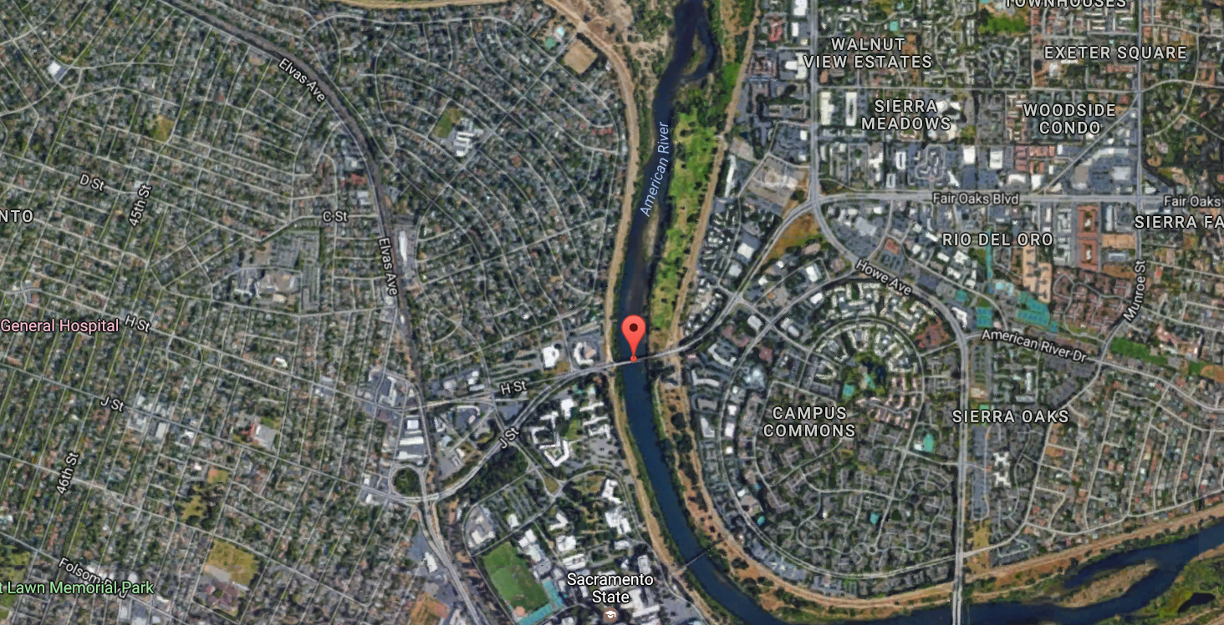

The bridge will replace the existing J St, Bridge near CSU Sacramento over the American River (38.568903, -121.423128). The proposed new bridge will carry 6 lines of traffic connecting J St. and Fair Oaks Blvd.

### Structural system

The type of the bridge is **cable stay bridge** with two towers on the east side of the river bank. The two tower are parallel and tilt to the east side. Both the towers are cone shapes and same design features. The Table 3.1 shows some dimensions of the design bridge.

**Table 3.1: Design Dimensions**

|  |  |  |  |
| --- | --- | --- | --- |
| Main Structure | Category | Size | Unit |
| Length | Deck | 525 | ft |
| Width | Deck | 89 | ft |
| Height | Tower | 228 | ft |
| Tilt Angle | Tower | 15 | -- |
| Diameter (Bottom) | Tower | 18 | ft |
| Diameter (Top) | Tower | 4 | ft |
| Height | Abutment | 22 | ft |

Codes and references

The design confirms the:

- ACI 318: Building Code Requirements for Structural Concrete (ACI)

- AISC Steel Construction Manual, 14th Edition (AISC)

- Some details part follow the special guides.

### Loading criteria and assumption

The design length of the main bridge is 525 feet and 50 feet above the water level. The service distributed live load is 0.64 kip / ft / lane and two 25 kip axles per lane spaced at 4 feet.

The reductor used for live load is 0.65. Follow the load combination in ACI, the Load = 1.2 Dead Load + 1.6 Live Load. The tandem load place on the left end of the bridge which will produce the extreme force effect.

#### Materials

The Materials used for the bridge design are summarized in the Table 3.2 below.

**Table 3.2 Material Properties**

|  |  |  |  |
| --- | --- | --- | --- |
| Member | Material | Grade | Unit |
| Deck | Concrete | 8 | ksi |
| Deck | Steel Rebar | 60 | ksi |
| Stringer | Steel | 50 | ksi |
| Girder | Steel | 50 | ksi |
| Edge Girder | Steel | 50 | ksi |
| Cable | Steel | 270 | ksi |
| Tower | Concrete | 6 | ksi |
| Tower | Steel Rebar | 60 | ksi |
| Abutment | Concrete | 6 | ksi |
| Abutment | Steel Rebar | 60 | ksi |
| Fundation | Concrete | 6 | ksi |

#### Geotechnical

The preliminary geotechnical assumption show in the Table 3.3 below.

Table 3.3: Geotechnical Assumption

|  |  |
| --- | --- |
| Limit State | Nominal Bearing Resistance, qn |
| Service | 20 ksf |
| Strength | 50 ksf |

#### Design of special conditions / elements

Basically, the bridge will carry the dead load of itself, the distributed live load, and a point lived load. The service distributed live load is 0.64 kip / ft / lane and two 25 kip axles per lane spaced at 4 feet.

For both distributed live load and dead load, the loads are transformed into distributed load (kips / ft2) to do the calculation.

The live load impact factor used for this bridge is 0.65, and the combination factors for live load and dead load are 1.6 and 1.2 (L = 1.2 LD + 1.6 LL).

The calculation of loads for superstructure is shown in the Appendix Excel file (A1).

Design of typical elements

##### i.Superstructure

There are 4 components for the superstructure: concrete slab, steel stringer, steel girder, and steel edge girder. There properties are shown in the Table below.

Superstructure Properties

|  |  |  |  |
| --- | --- | --- | --- |
| Components | Material | Grade | Notes |
| Slab | Concrete | 8 ksi | Steel ratio in the concrete is 2% |
| Steel Rebar | 60 ksi |
| Stringer | Steel | A572 (50 ksi) | W30 391 |
| Girder | Steel | A572 (50 ksi) | Built up W shape 22”4” Flange, 4”22” Web |
| Edge Girder | Steel | A572 (50 ksi) | Built up HSS, 12”78”2” for deck #1 - #8, 24”78”2” for deck # 9 - #17 |

The capacity design for each member basic follow the AISC codes. For stringer and girder, the local buckling and lateral buckling are the mainly checking parts. For Edge girder, the overall buckling is the key factor to determine the capacity. For all the member, the required shears are much smaller than the capacity.

The compression elements checking using the Table below.

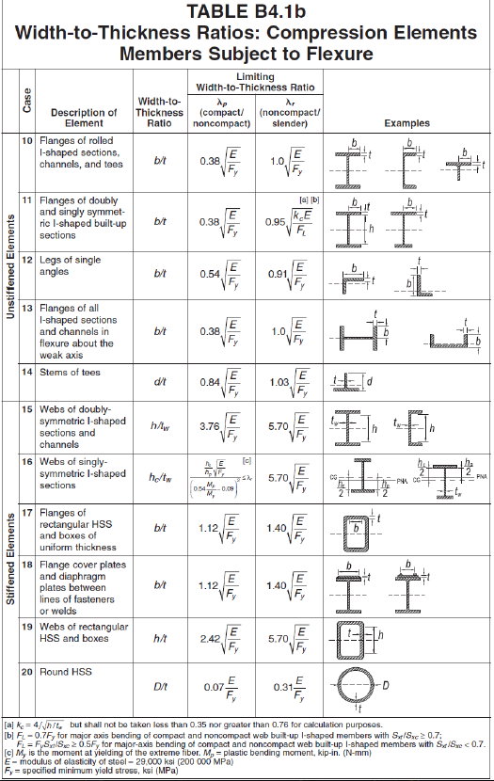

Equation used for Lateral buckling

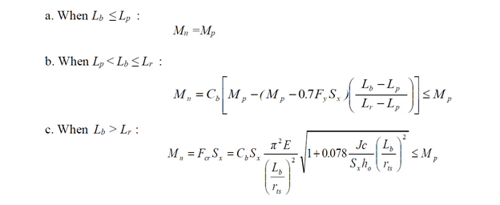

Where

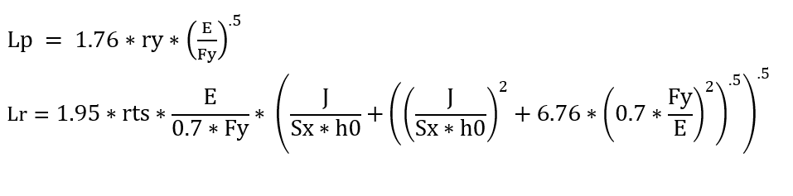

Shear Design

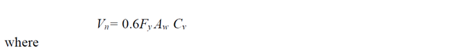

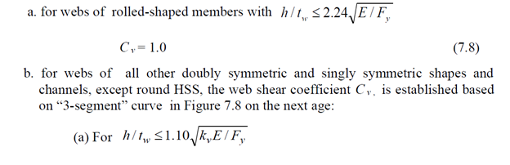

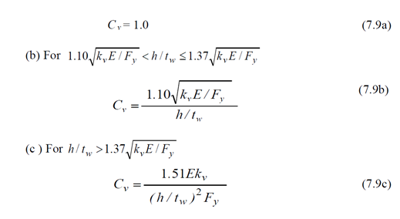

Equation for Overall buckling

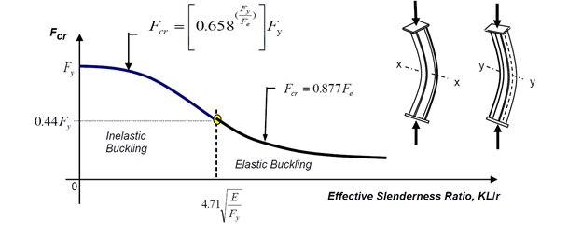

Where Fe determined by Euler’s Buckling Equation 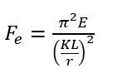

K = 1.0 (pin-pin condition) for edge girder

The table used to check local buckling

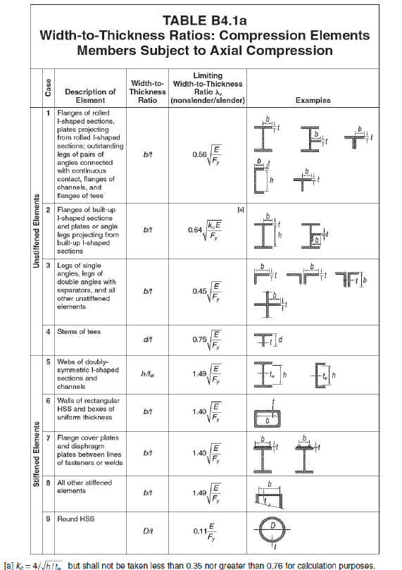

The capacities of the members are summarized in the table below.

|  |  |  |  |
| --- | --- | --- | --- |
|  | Stringer | Girder | Edge Girder |
| Local Buckling (k-ft) | Compact | Compact | Compact |
| Overall bucking (kips) | -- | -- | 16045* |
| Lateral Buckling (k-ft) | 5267 | 8955 | 13911 |
| Shear (kips) | 1554 | 4560 | 4920 |
| *Note: The concrete slab will carry part of compression (474 ksi) | | | |

There are shear studs will connect the concrete slab to the edge girder to resist a part compression in the edge girder.

Because the compression will decrease along the edge girder, there are two type of edge girder. The strong one has a large capacity with dimension 24” * 78” * 2”, and the small one has a dimension 12” * 78” * 2”.

The figure shows the axial compression along the girder.

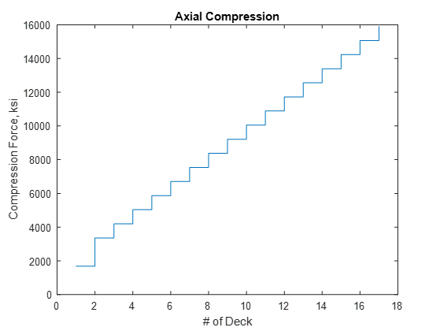

##### ii.Front Cable

The cable consists with the seven-wire strand. Some properties of the material are listed below.

Table: Properties of Seven-Wire Strand Cable

|  |  |
| --- | --- |
| Seven-Wire Strand Cable | Properties |
| Diameter | 15.7 mm |
| Effective Area | 150 mm |
| Grade | 270 |
| Tensile Capacity | 62.775 ksi |

The front cable designed for the bridge consisted with 37 seven-wire strand. The total tensile capacity for the front cable is 2323 ksi.

There are 16 front cables (each side) to carry all the load from the deck and the girders. The ratio of height over length is 1:2.5.

##### iii.Back Cable

The back cable consisted with the same material as the front one. The number of strand for each back cable is 127, which will create a 7972 ksi tensile capacity.

There are 6 back cables (each side) to balance the moment created by the front cable.

##### iv.Pylon

There are two parallel pylons both on the east side of the river. The two pylons have the exact same design. The basic dimensions for the pylons are listed in the Table below.

Table: Properties of Pylons

|  |  |  |  |
| --- | --- | --- | --- |
| Pylon (each) | | Quantity | |
| Shape | | Cone | |
| Height (ft) | | 228 | |
| Length (ft) | | 236.04 | |
| Tilt Angle (Deg) | | 15 | |
| Bottom Diameter (ft) | | 18 | |
| Top Diameter (ft) | | 4 | |
| Materials | Steel (ksi) | 60 | Steel ratio is 0.02 |
| Concrete (ksi) | 6 |
| Weight (ksi) | | 4000 | |

The capacity design for each member basic are very close to the design method above. The moment of the pylons and the compression of the pylons are the main design parts.

The moment design use the equation . The equation basically use for rectangular box design. Therefore, b = r, d = 2r for this design.

The axial force design follow the same step above (overall buckling), but change the Euler number K to 2 (fix and free).

The cross beam between the pylons only resist the compression force. Therefore, check the overall buckling same as above.

The design capacities are shown below.

Table: Pylons

|  |  |
| --- | --- |
| Variables | Quantity |
| Moment | 4.8*10^6 k-ft |
| Axial Force | 9.6*10^4 kips |
| Axial Force (Cross Beams) | 5584 kips |

### Foundation

The foundation systems consisted with 2 parts. The abutment for the west side and the deep foundation on the east side of the river.

#### East side foundation

Because the pylons are on the east side of the bridge, the compression from the edge girder will cause a large shear and compression on the east side bank. Therefore, the east side cannot use the soil to resist the forces. Meanwhile, the back cable need to be anchored on the east side foundation.

The design is to use concrete fill the top 10 feet ground surface to resist the compression force. However, for the back part, the foundation should touch the bedrock and anchored the back cable into the rock and use concrete to enforce the connection part.

#### 

#### 

#### **Abutment**

The left side of the abutment will not resist the horizontal force from the superstructure. Therefore, the design only resist the load from the last segment of the deck and the soil pressure from the bank.

The detail designs are shown below.

The abutment is a reinforced concrete abutment with stem of 20 feet height and and 4 feet thickness. The type of abutment we choose is open end short stem seat. The seat width is thirty six inches wide. . The foundation for the abutment is two feet deep and ten by ten feets.The ratio of steel reinforcement is 0.2 percent.

We design the foundation of the abutment based on the allowable soil pressure at service area. Then we used the $q(net)=Pu/A$. We evaluate the one way and two ways shear and the flexure of the foundation. Based on our calculation we needed 20 #6, more details for the anchorage length and bearing between the stem and footing to be done.

The stem design was based on the soil pressure on the wall. We designed the stem to be adequate for shear and moment at the bottom which is the critical part.

The equations used are below.

Vc=0.75*2*Sqrt(4000)*b*d

Mu=0.9*As*fy*b*d(1-0.59*As*fy/(fc*b*d))

Vu=0.75*Vc

The load analysis we have done is based on AASHTO 2010.

**Undeformed Shape**

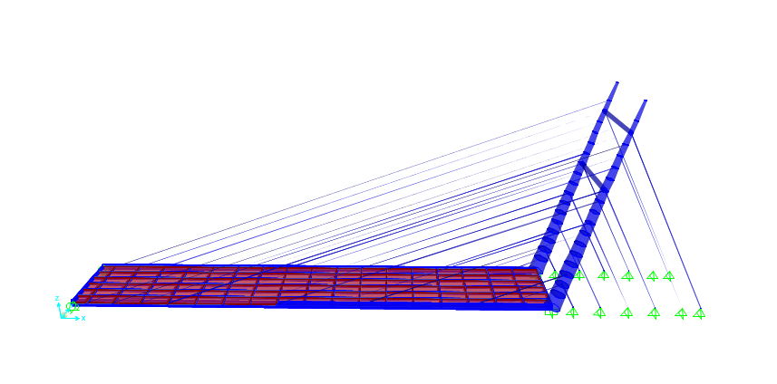

**Figure. 1**

Load combination one

A live load of 0.64 k/ft/lane and two 25k/lane four feet apart to represent a random cars moving on the bridge. During this load combination we do not account to any wind load.

Load combination two

The dead load with 1.25 factor represent the gravity load of the structure with safety factor.

Load combination three

The other load combination we used is the earthquake load of 0.15 of Deal load.

Results:

Moving load deflection **Figure. A**

Moving load and dead load combination deflection **Figure. B**

Dead load deflection **Figure.C**

The model deflection **Figure. D**

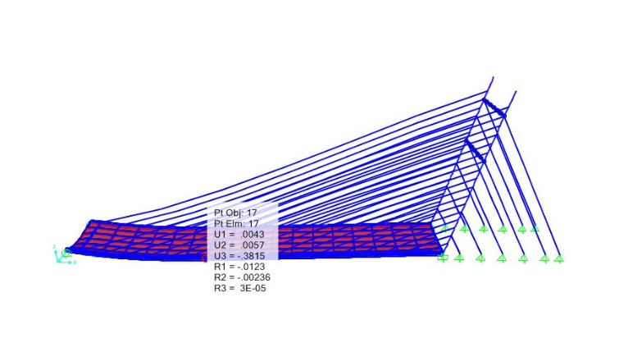

**Figure. A**

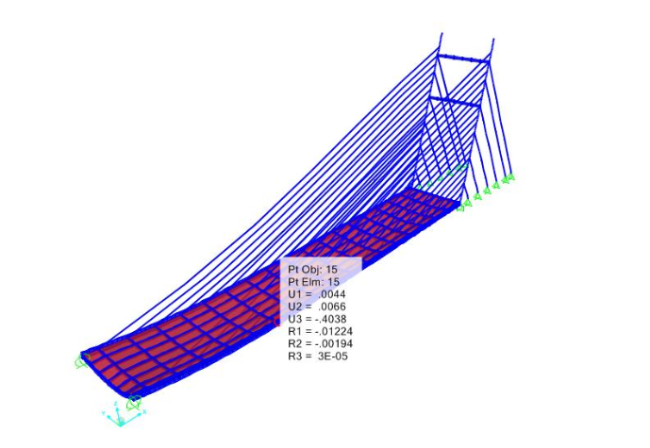

**Figure. B**

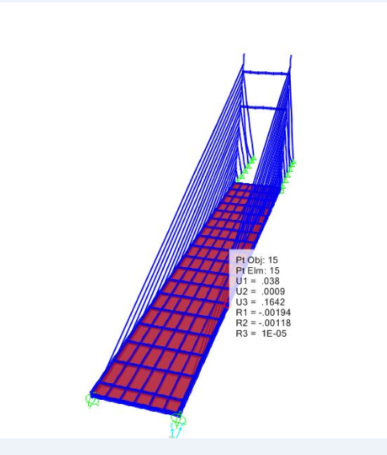

**Figure.C**

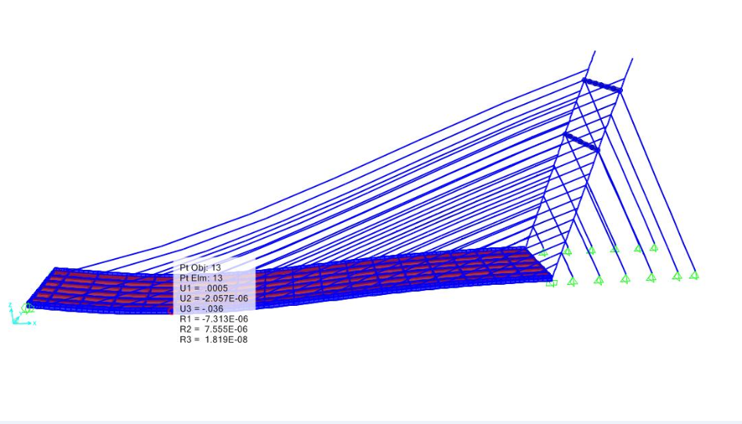

Figure. D

The lane loads **Figure.E**

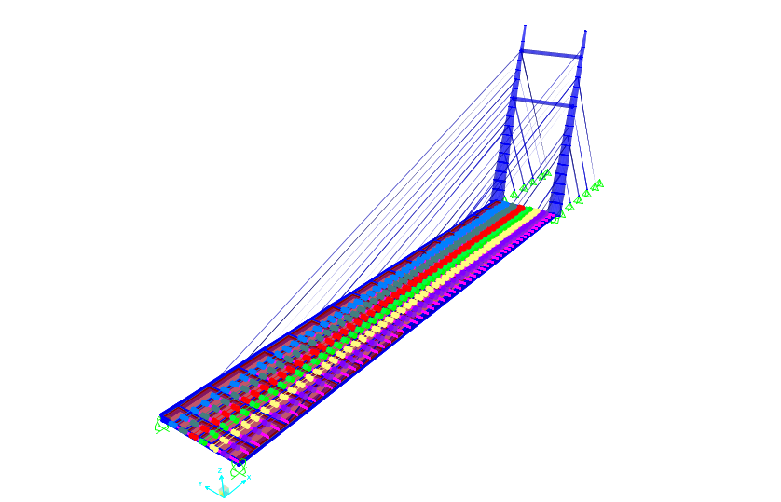

**Figure. E**

#### 

#### 

#### 

#### 

#### 

#### 

#### 

#### 

#### 

#### **Constructability**

The construction of the cable stay bridge.

Step one:

Construct the adequate foundations and the abutment

Step two:

Construct the pylons

Step three:

Add the cable based on the deck constructions

Step four:

Add the deck sections of 60 ft long

The deck and cable construction will go hand by hand.

We recommended a use of cranes and ships to construct the deck which allow for minimum risk.

**Design Drawings**

Elevation view of proposed structure

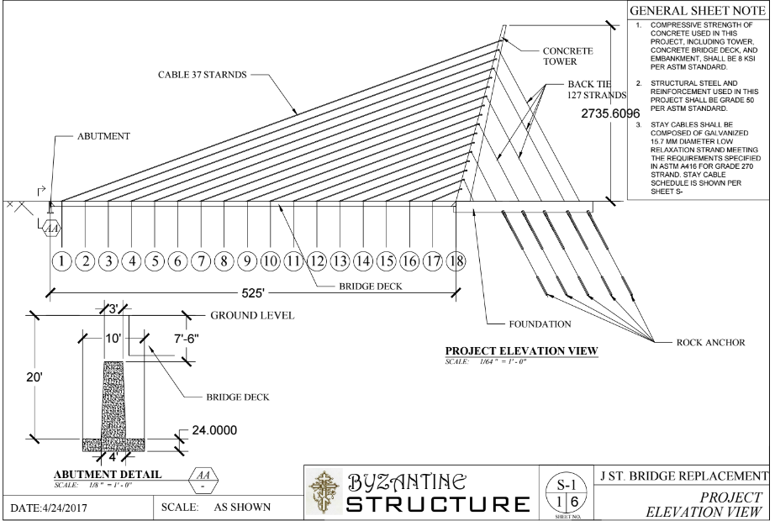

Plan view of proposed structure:

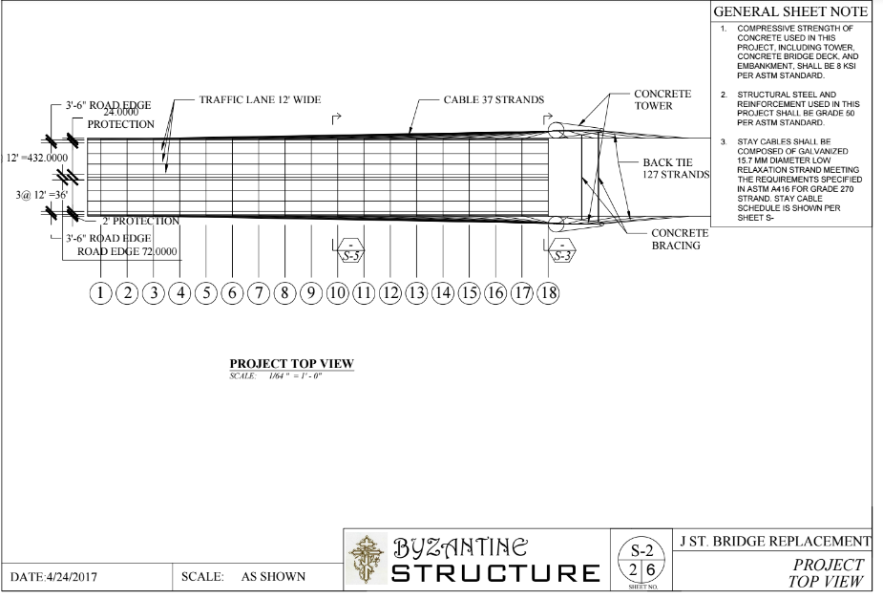

Tower Cross Section

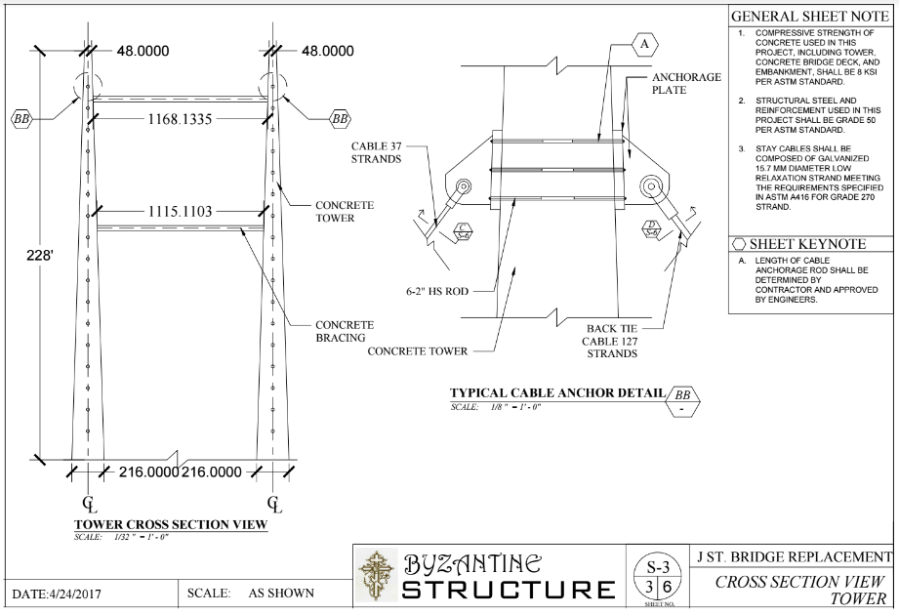

Bridge Deck Cross Section

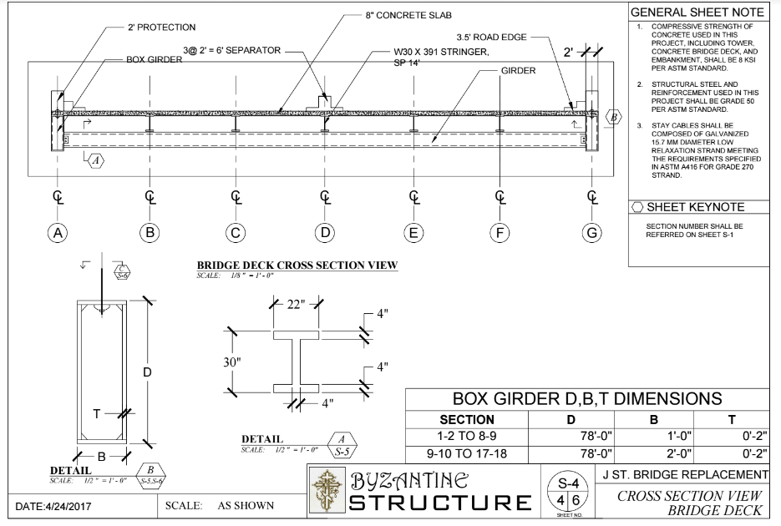

Bridge Framing Plan

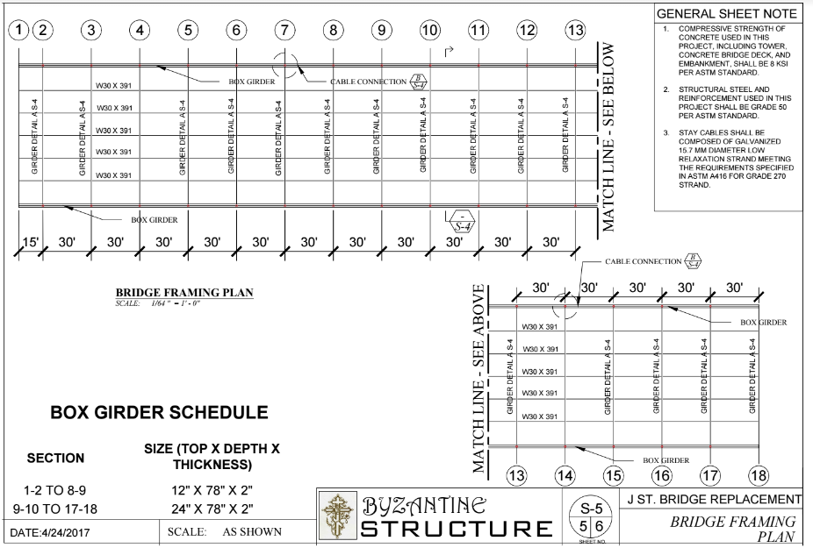

Cable

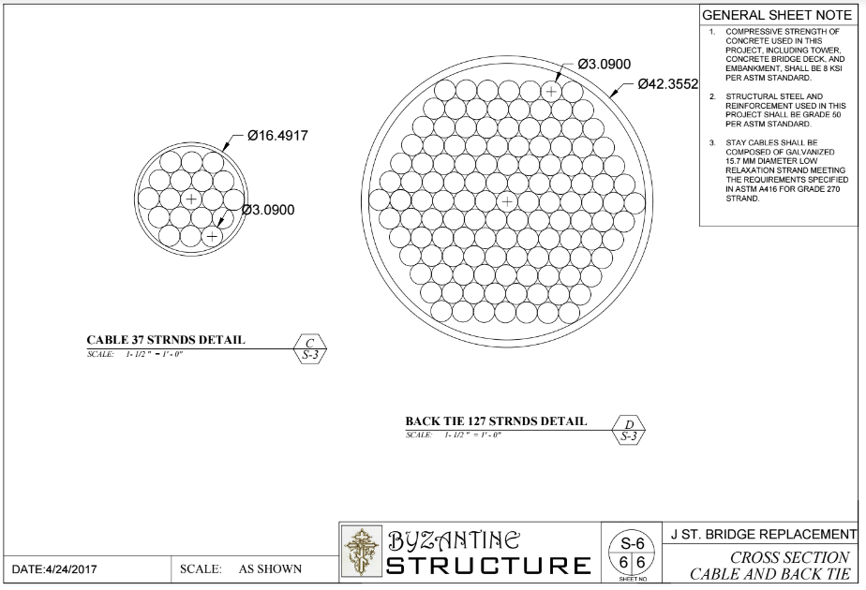

## Appendix

Excel Load Calculations Sheet

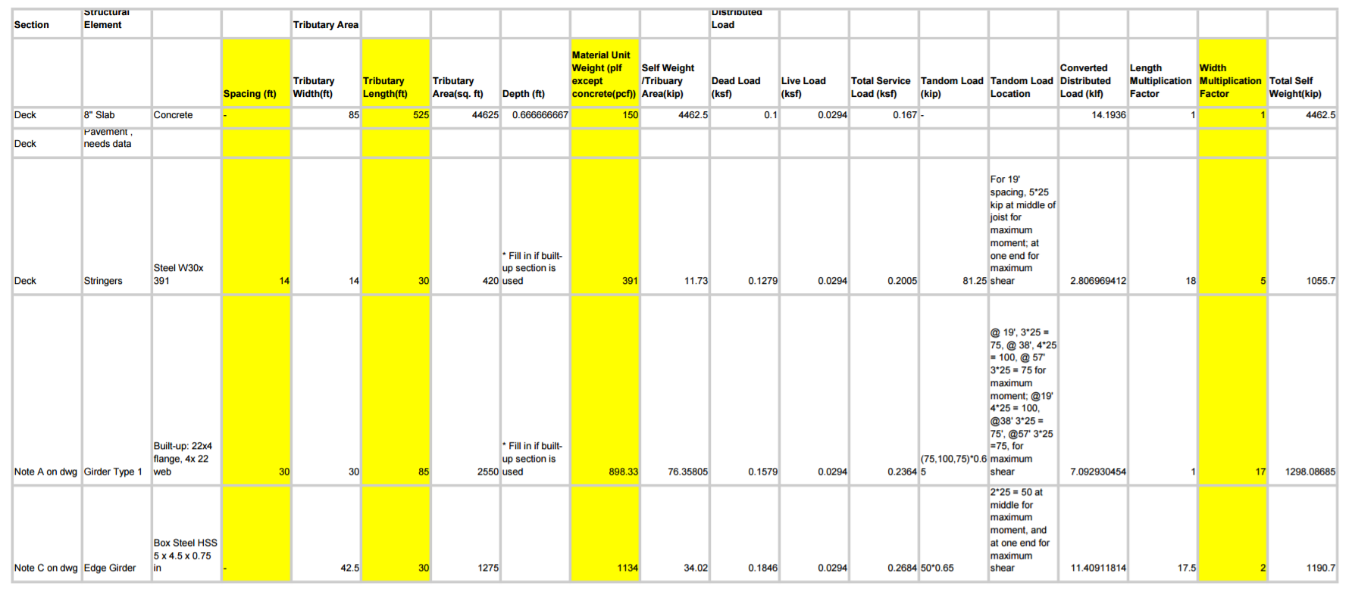

**Matlab Codes and Design Tools**

Beam Capacity Check:

clear all; clc

Lb = 25*12;

E = 29000; Fy = 50;

A = 115; tf = 2.44; bf = 15.6; h = 26.5; tw = 1.36 ; d = 33.2; Cb = 1.14;

ry = 0; %% if do not know, ry = 0

rts = 0; %% if do not know, rts = 0

J = 0; %% if do not know, J = 0

Sx = 1250; %% if do not know, Sx = 0

Z = 0;

h0 = d-tf;

if ry==0

Iy = tf*bf^3/6;

ry = (Iy/A)^.5;

end

if J == 0;

J = 1/3*(bf*tf^3*2 + h*tw^3);

end

if Sx == 0

y = (tf*2+h)/2;

Ix = (bf*tf^3*2 + tw*h^3)/12+ bf*tf*(y-tf/2)^2*2;

Sx = Ix / y;

end

if rts ==0

Iy = tf*bf^3/6;

rts = (Iy*h0/2/Sx)^.5;

end

if Z == 0

y = (tf*2+h)/2;

Z = tf*bf*(y-tf/2)*2 + h/2*tw*h/4*2;

end

Mp = Z * Fy;

%%%%%%%%%%%%%%%%%%%%%%%%%%%%%%%%%

Lp = 1.76*ry*(E/Fy)^.5;

Lr = 1.95*rts*E/(0.7*Fy)* (J/(Sx*h0)+((J/(Sx*h0))^2+6.76*(0.7*Fy/E)^2)^.5)^.5;

if Lb <= Lp

disp('case 1');

Mn = Mp;

elseif Lb <= Lr

Mn = Cb*(Mp - (Mp-0.7*Fy*Sx)*((Lb-Lp)/(Lr-Lp)))

if Mn >= Mp

Mn = Mp;

end

disp('case 2');

else

Mn = Cb * Sx*pi^2*E/(Lb/rts)^2* (1+0.078*J/Sx/h0*(Lb/rts)^2)^.5

if Mn >= Mp

Mn = Mp;

end

disp('case 3');

end

disp('Mn in feet');

Mn = Mn /12

Mu = 0.9 * Mn

Lateral Buckling

clear all; clc

% require 7371

Lb = 85*12;

E = 29000; Fy = 50;

A = 376; tf = 2; bf = 24; tw = 4; d = 78; Cb = 1.14;

h = d - 2*tf;

ry = 0; %% if do not know, ry = 0

rts = 0; %% if do not know, rts = 0

J = 0; %% if do not know, J = 0

Sx = 0; %% if do not know, Sx = 0

Z = 0;

h0 = d-tf;

if ry==0

Iy = tf*bf^3/6;

ry = (Iy/A)^.5;

end

if J == 0;

J = 1/3*(bf*tf^3*2 + h*tw^3);

end

if Sx == 0

y = (tf*2+h)/2;

Ix = (bf*tf^3*2 + tw*h^3)/12+ bf*tf*(y-tf/2)^2*2;

Sx = Ix / y;

end

if rts ==0

Iy = tf*bf^3/6;

rts = (Iy*h0/2/Sx)^.5;

end

if Z == 0

y = (tf*2+h)/2;

Z = tf*bf*(y-tf/2)*2 + h/2*tw*h/4*2;

end

Mp = Z * Fy;

%%%%%%%%%%%%%%%%%%%%%%%%%%%%%%%%%

Lp = 1.76*ry*(E/Fy)^.5;

Lr = 1.95*rts*E/(0.7*Fy)* (J/(Sx*h0)+((J/(Sx*h0))^2+6.76*(0.7*Fy/E)^2)^.5)^.5;

if Lb <= Lp

disp('case 1');

Mn = Mp;

elseif Lb <= Lr

Mn = Cb*(Mp - (Mp-0.7*Fy*Sx)*((Lb-Lp)/(Lr-Lp)))

if Mn >= Mp

Mn = Mp;

end

disp('case 2');

else

Mn = Cb * Sx*pi^2*E/(Lb/rts)^2* (1+0.078*J/Sx/h0*(Lb/rts)^2)^.5

if Mn >= Mp

Mn = Mp;

end

disp('case 3');

end

disp('Mn in feet');

Mn = Mn /12

Mu = 0.9 * Mn

Local Buckling Check

bf = 11.6; tf = 1.91;

z = 490; Fy = 50; Sx = 419; h = 15.5; tw = 1.06; E = 29000;

lam_pf = 0.38*(E/Fy)^0.5; lam_rf = (E/Fy)^0.5;

Mp = z* Fy

lamda = bf/2/tf;

if lamda <= lam_pf

Mn = Mp / 12

elseif lamda <= lam_rf

Mn = Mp - (Mp - 0.7*Fy*Sx)*((lamda-lam_pf)/(lam_rf-lam_pf)) / 12

else

kc = 4 / (h/tw)^0.5;

if kc < 0.35

kc = 0.35;

elseif kc> 0.76

kc = 0.76;

end

Mn = 0.9*E*kc*Sx / lamda^2 / 12

end

Overall Buckling

clear all; clc;

Kx = [1.0];

Ky = [1.0];

L = [89*12];

rx = 12; ry = 12;

E = 3600; Fy = 6; Ag = 12.57*144;

KL_r = max([Kx.*L/rx; Ky.*L/ry]);

Fe = pi^2*E./(KL_r).^2;

for i = 1:numel(KL_r)

if KL_r(i) <= 4.71*(E/Fy)^.5

Fcr(i) = 0.658^(Fy/Fe(i)) * Fy;

else

Fcr(i) = .877*Fe(i);

end

end

Pu = 0.9 * Fcr * Ag

Buckling Check

clear all; clc;

Kx = [1.2 2 2 2];

Ky = [.8 1 1 1];

L = [144 17*12+6 14*12+6 144];

rx = 5.51; ry = 3.13;

E = 29000; Fy = 50; Ag = 35.2;

KL_r = max([Kx.*L/rx; Ky.*L/ry])

Fe = pi^2*E./(KL_r).^2;

for i = 1:numel(KL_r)

if KL_r(i) <= 4.71*(E/Fy)^.5

Fcr(i) = 0.658^(Fy/Fe(i)) * Fy;

else

Fcr(i) = .877*Fe(i);

end

end

Box girder flexural iterative design tool

Pu = 0.9 * Fcr * Ag

E=29000; %Specify Elastic Modulus

Fy=50; %Specify Fy

d=40;%specify depth in inches

tf=2.5;%specify flange thickness in inches

bf=40;%specify breadth of flange in inches

tw=2.5;%specify thickness of web in inches

h=d-tf*2;

d1=d-tf/2;

d2=bf/2;

A1=2*bf*tf;

A2=4*(h/2)*tw;

%Check Local buckling of Compression Flange

lambda=bf/tf;

lambdapf=1.12*sqrt((E/Fy));

lambdarf=1.4*sqrt(E/Fy);

% Variables

Ixx=2*bf*(tf^3)/12 +bf*tf*(bf/2-tf)+2*tw*(h^3)/12 +h*tw*(h/2-tw); %Check the d with yanlong for Ad^2

beff=1.92*tf*sqrt(E/Fy)*(1-(0.38/(bf/tf))*sqrt(E/Fy));

Seff=Ixx/beff;

Zx=0.25*(bf*((h+2*tw)^2)-(bf-2*tf)*h^2); %Z outer rectangle- Z inner rectangle

Mp=Fy*Zx; %Mp=Fy*Zx

Sx=Ixx/(h/2-tf);

%Check for local buckling

if lambda<lambdapf

result='Section is Compact, No Local Buckling'

Mn=Mp;

elseif lambda>lambdapf && lambda<lambdarf

result='Inelastic Flange Local Buckling'

Mn=Mp-(Mp-Fy*Sx)*(3.57*bf/tf)*(sqrt(Fy/E)-4.0);

else

result='Inelastic Flange Local Buckling'

Mn=Fy*Seff;

end

Mn=num2str(0.9*Mn/12); %Mu in Kip foot, multiplied by safety factor 0.9

Mu=['Mu is ',Mn,' kipfoot']

Shear Checks

I_roll = 0; %% 1 if rolled I shape, 0 others

stiffen = 0; %% 0 if unstiffened, other 1

E = 29000; Fy = 50;

Cv = 0; %% initial

h = 26.5; tw = 1.36; bf = 15.6; tf = 2.44; %a = 25; % spacing

if h/tw <= 2.24*(E/Fy)^.5

phi = 1;

Cv = 1;

else

phi = 0.9;

end

if h/tw < 260 && stiffen == 0

kv = 5;

else

kv = 5 + 5/(a/h)^2;

if a/h >3 || a/h > (260/(h/tw))^2

kv = 5;

end

end

if Cv == 1 || h/tw <= 1.1*(kv*E/Fy)^.5

Cv = 1;

elseif h/tw <= 1.37 * (kv*E/Fy)^.5

Cv = 1.1*(kv*E/Fy)^.5 / (h/tw);

else

Cv = 1.51*E*kv / ((h/tw)^2*Fy);

end

Aw = (h + 2*tf)*tw;

Vn = 0.6*Fy*Aw*Cv;

Vu = phi*Vn

%% check stiffened

J = 2.5 / (a/h)^2 -2;

Iww = a * tw^3* J